**MEDICAL INVENTORY MANAGEMENT**

**COLLEGE NAME** : UNITED COLLEGE OF ARTS AND SCIENCE

**COLLEGE CODE** : brubl

**TEAM ID** : NM2025TMID27799

**TEAM MEMBERS** :

Team Leader Name : MAHESWARI S

Email Id : maheswarisucas@gmail.com

Team Member 1 : GOKULNATH R

Email Id : r.s.gopiselvi@gmail.com

Team Member 2 : HARIHARAN M

Email Id : hr292853@gamil.com

Team Member 3 : HARISHRAGAVENTHIRA S

Email Id : harisucas587@gmail.com

**1.INTRODUCTION**

The Medical Inventory Management in Salesforce project aims to design and implement a comprehensive solution to efficiently manage the storage, tracking, distribution, and reporting of medical supplies and equipment using the Salesforce platform. This system is tailored for healthcare organizations, clinics, hospitals, and medical suppliers who need real-time visibility, automation, and control over their inventory lifecycle.

By leveraging the powerful tools of Salesforce CRM, such as Salesforce Health Cloud, Salesforce Lightning, Custom Objects, Flows, and Reports & Dashboards, the solution enables seamless integration between inventory data, user roles (like warehouse staff, medical professionals, and procurement teams), and patient care workflows.

**1.1 PROJECT OVERVIEW**

The Medical Inventory Management System (MIMS) is a digital solution designed to streamline and automate the tracking, storage, and distribution of medical supplies, equipment, and pharmaceuticals within healthcare facilities. The system ensures optimal stock levels, minimizes waste, improves compliance, and supports better healthcare delivery by ensuring the right medical products are available when and where they are needed.

**1.2 PURPOSE**

The purpose of the Medical Inventory Management System is to develop an efficient, reliable, and user-friendly platform for managing the storage, movement, and monitoring of medical supplies and equipment within healthcare facilities. The system aims to address the challenges of manual inventory tracking, such as stockouts, overstocking, expired items, and human errors, by providing a centralized and automated solution.

**DEVELOPMENT PHASE**

Creating Developer Account : <https://developer.salesforce.com/signup>

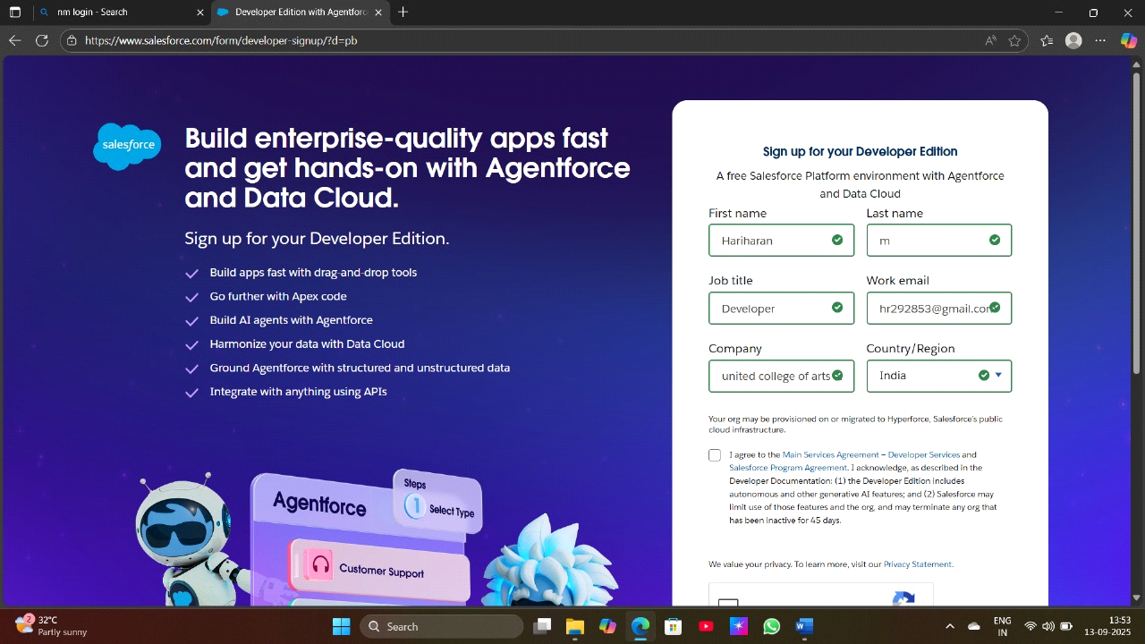

**Creating a Product Object** :

Product ,Purchase Order, Order Item, Inventory Transaction and Supplier objects.

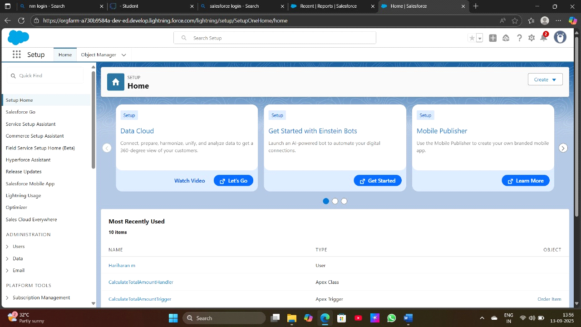

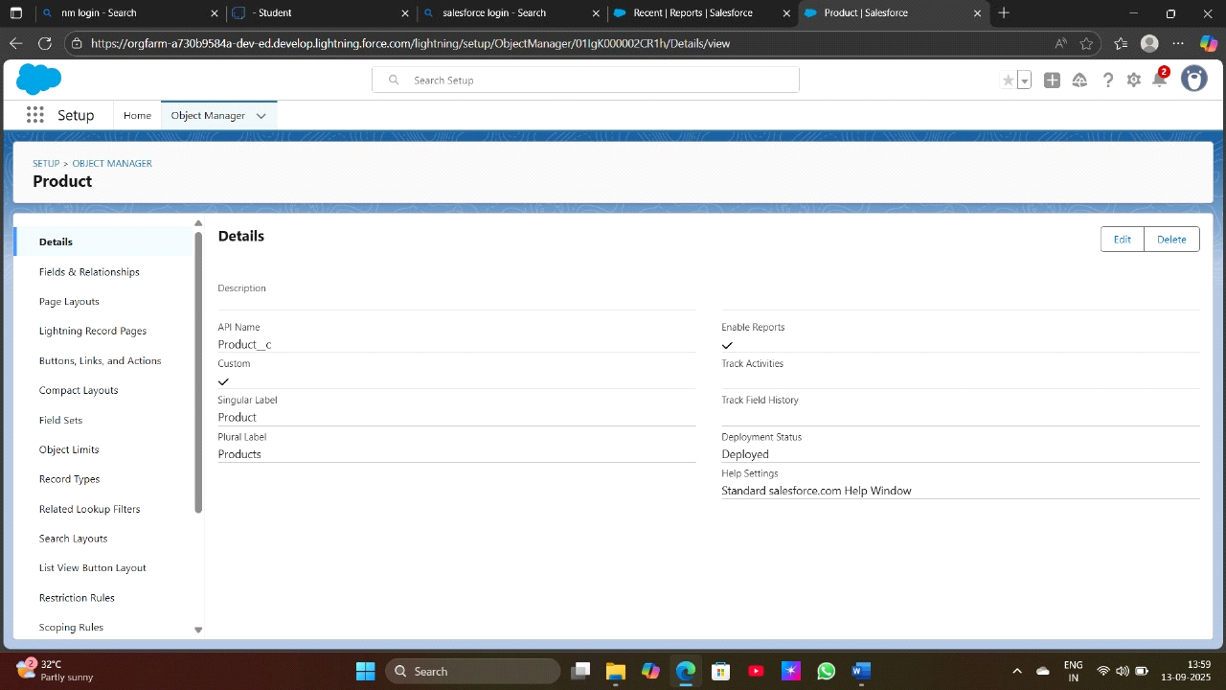

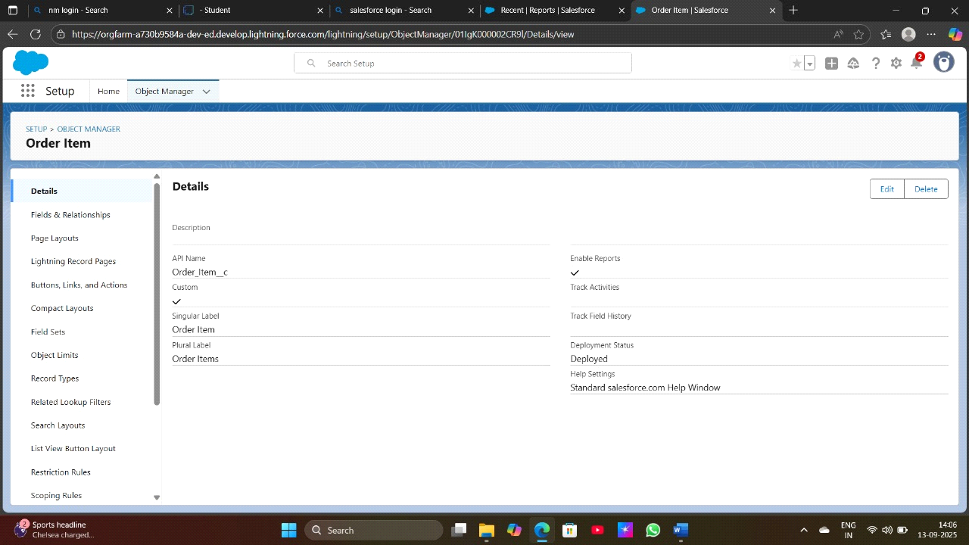

**Creating a tab for Object**

Product,Purchase Order, Order Item, Inventory Transaction, Supplier

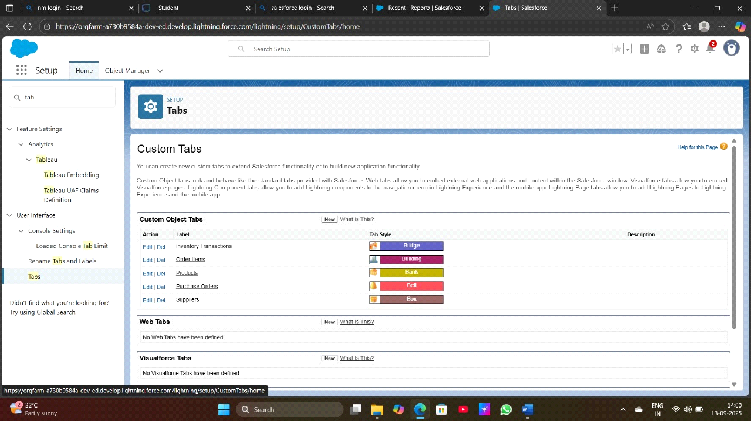

**Create a Lightning App for Medical Inventory Management**

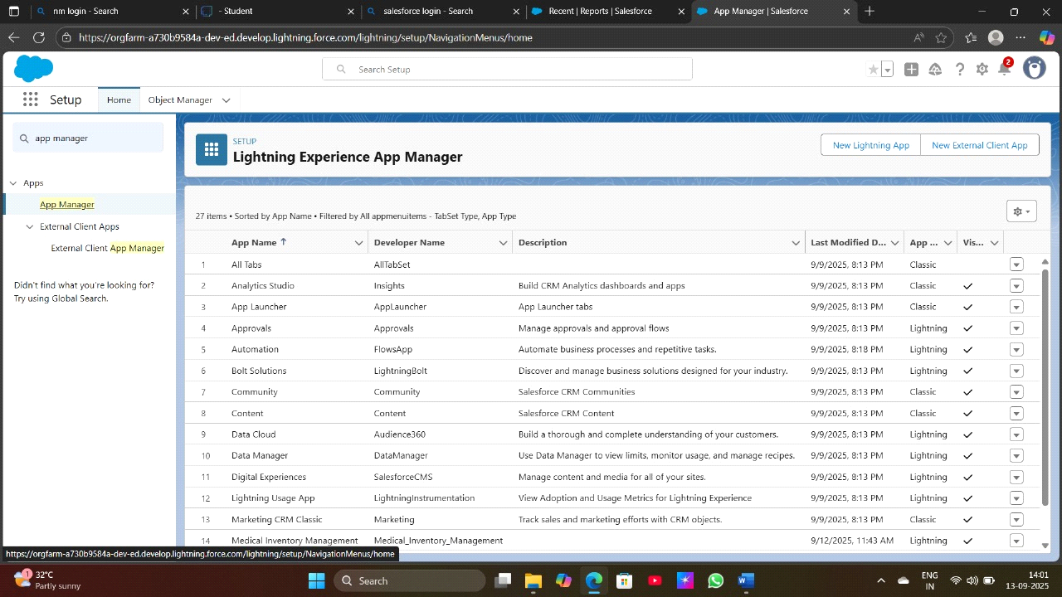

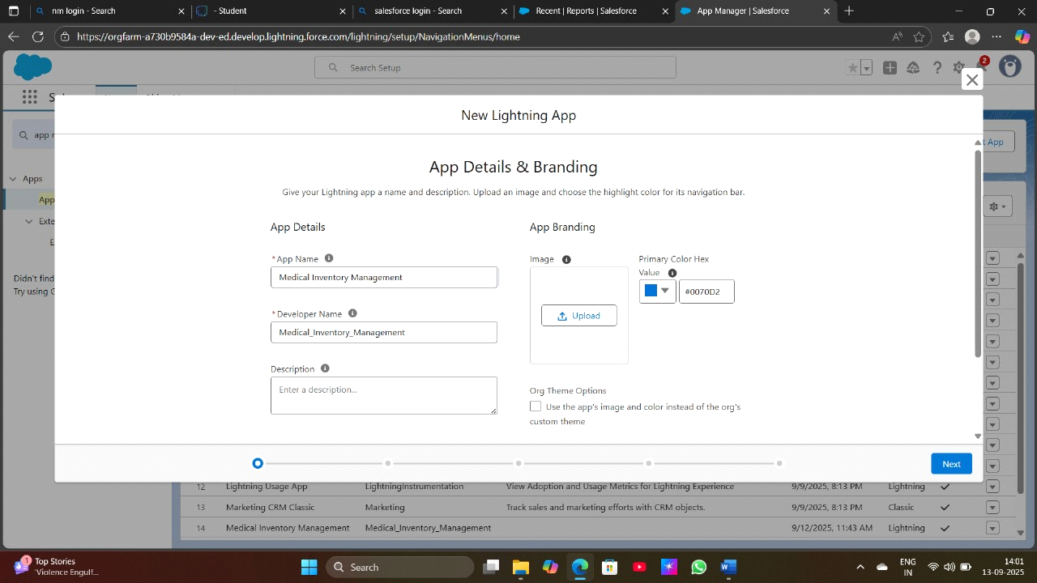

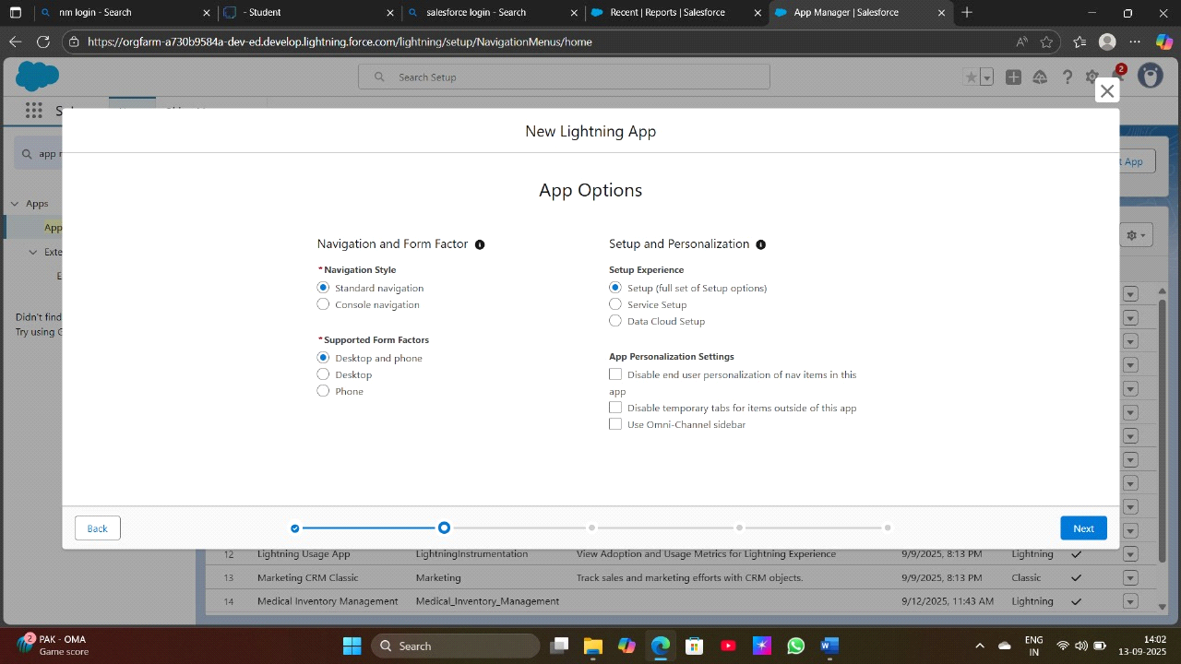

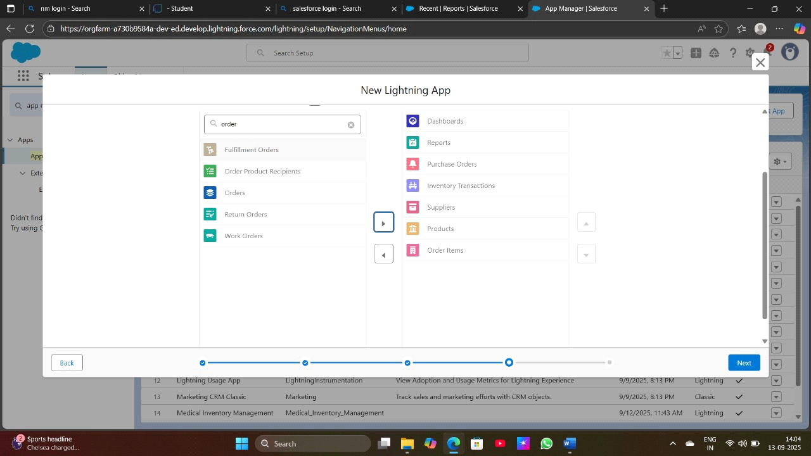

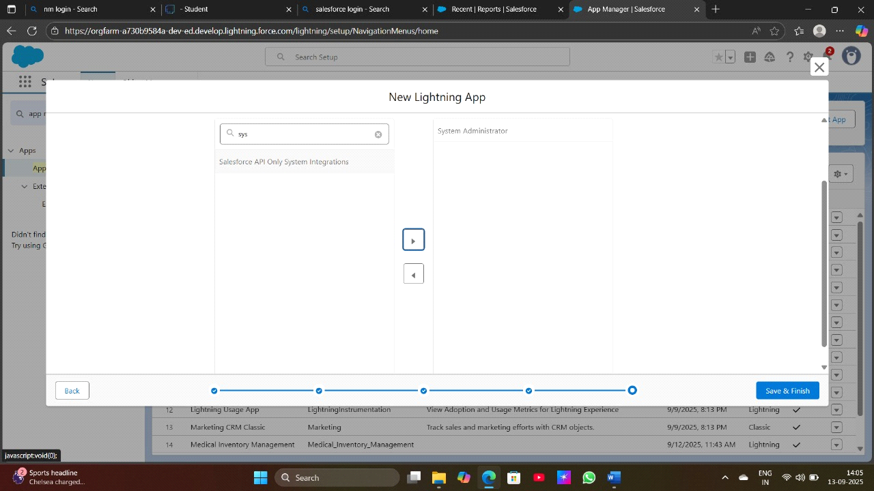

**Create a Fields**

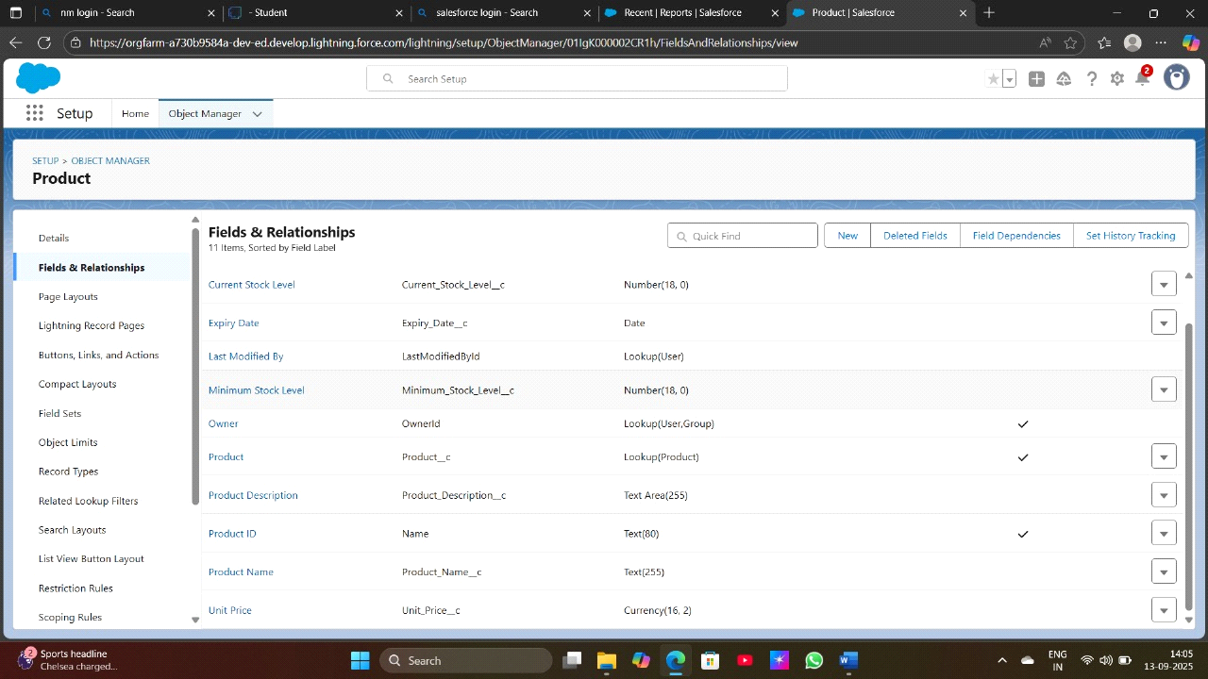

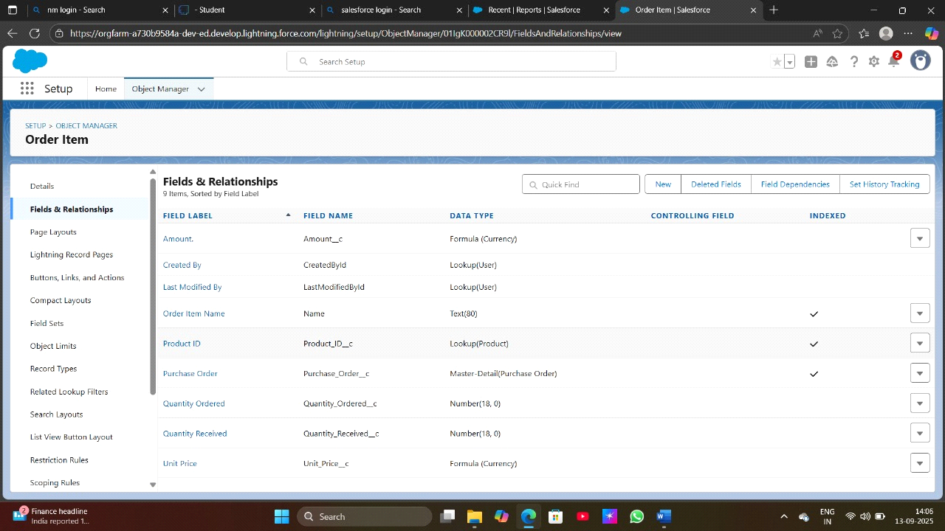

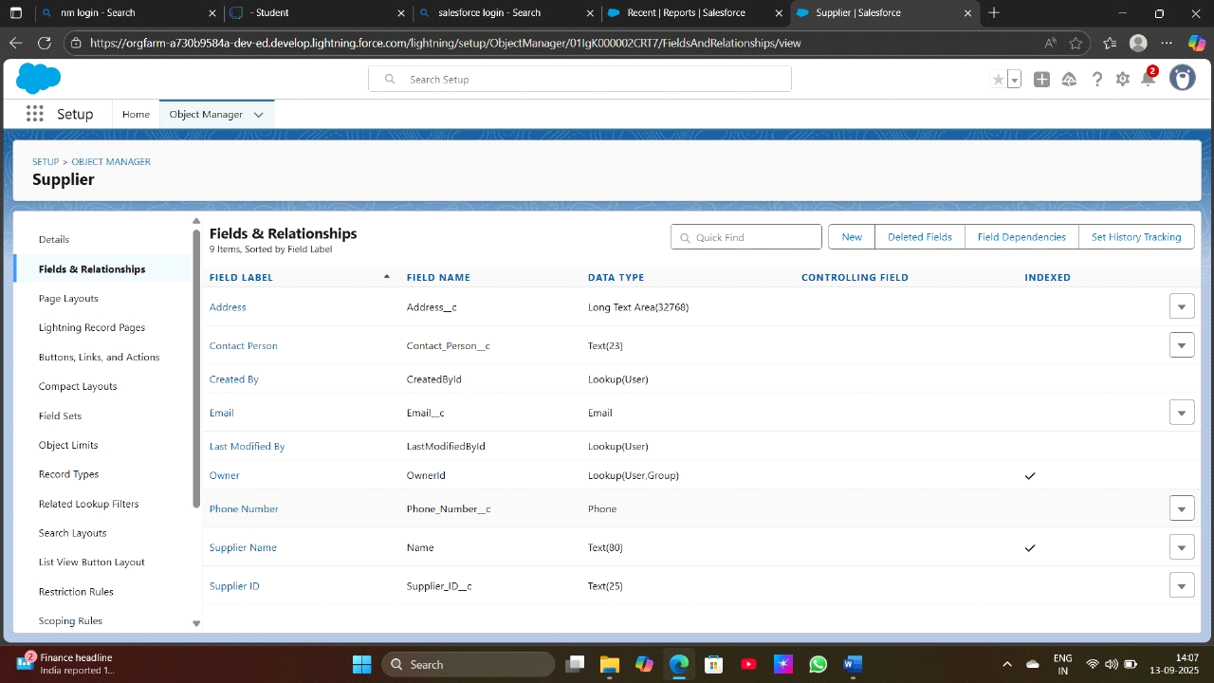

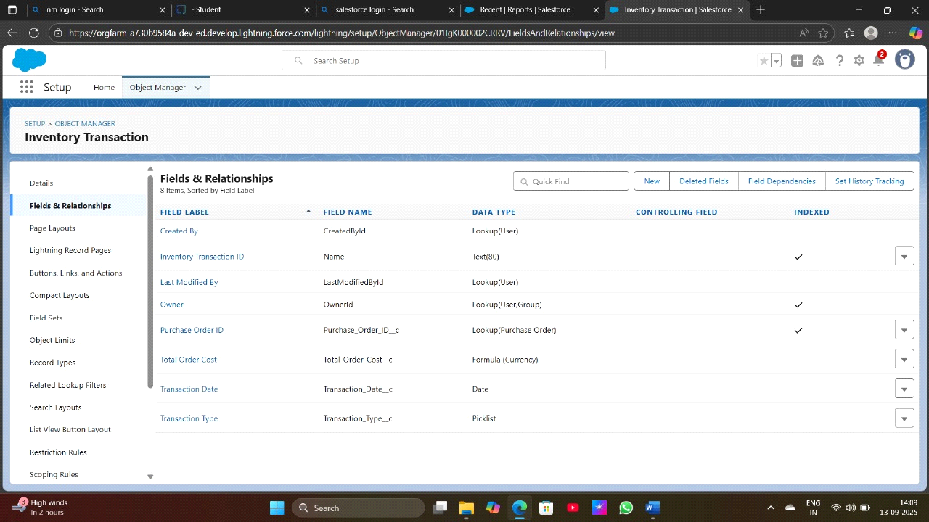

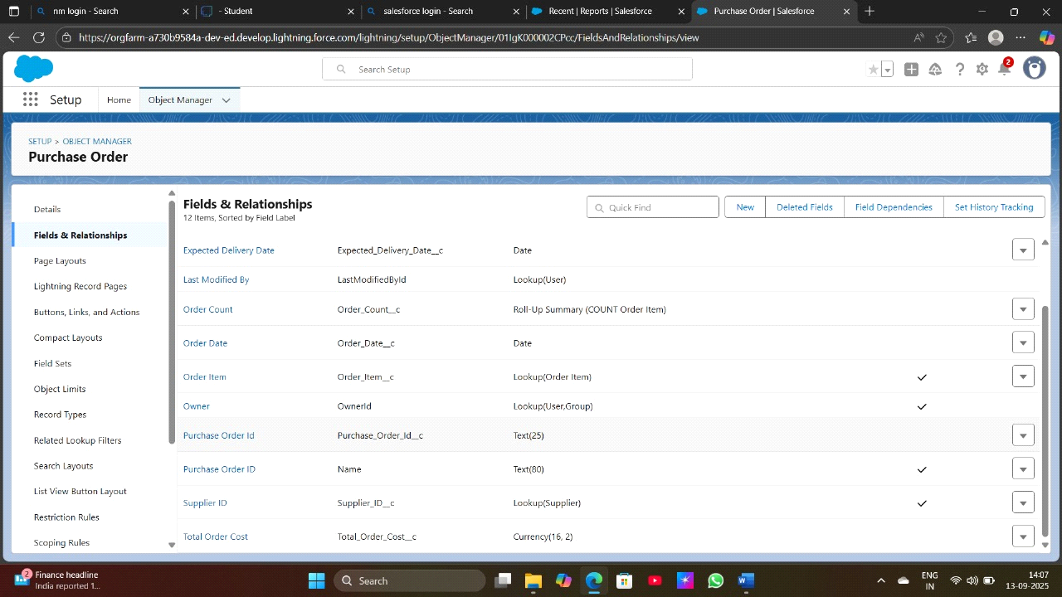

**Editing a Page Layouts**

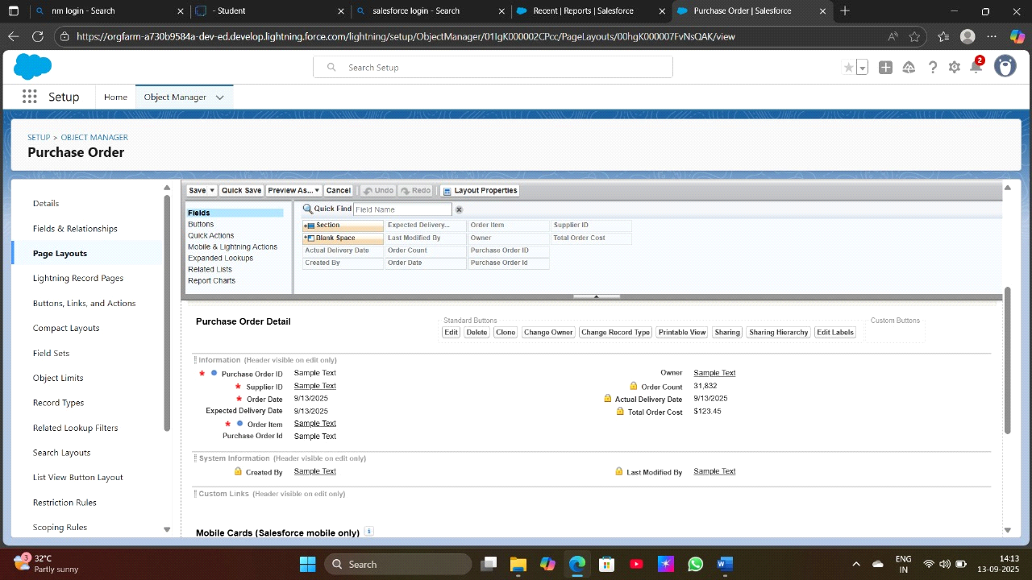

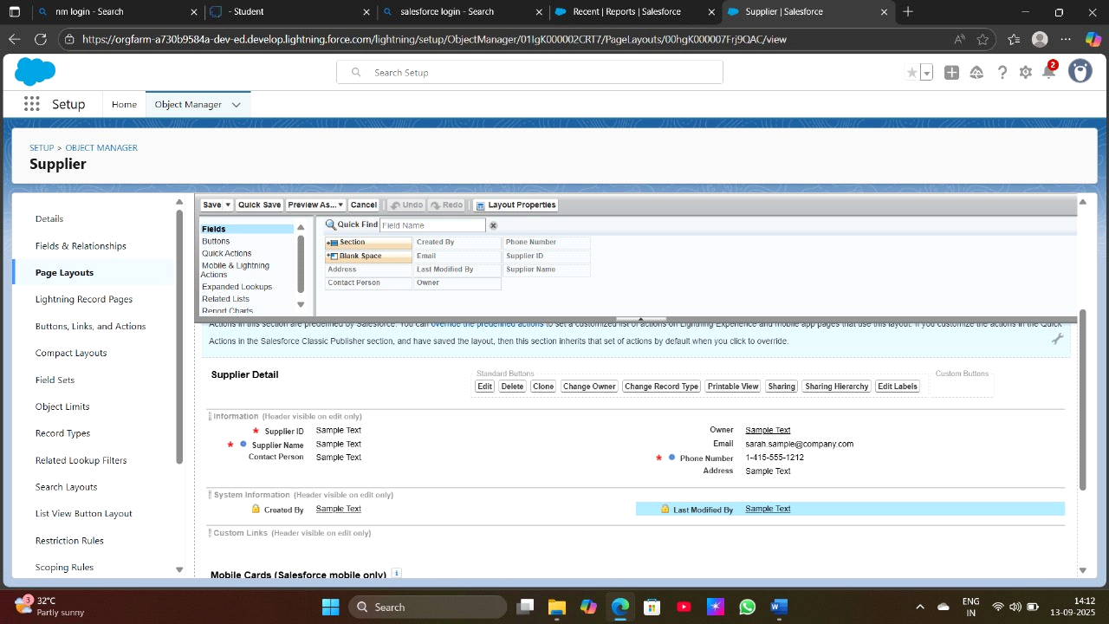

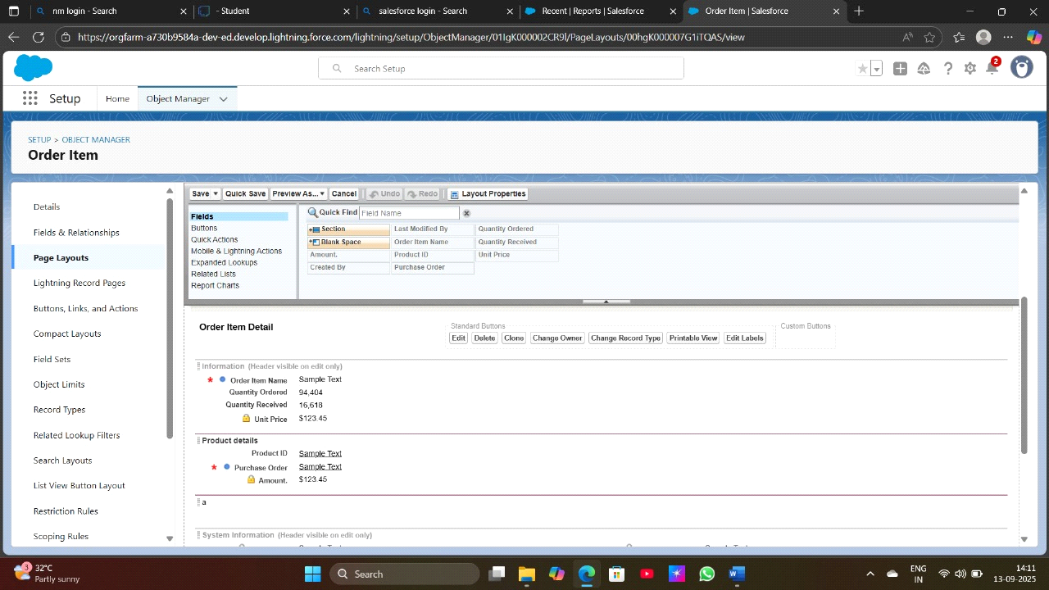

**To create a Compact Layout**

Product Object ,Purchase Order Object

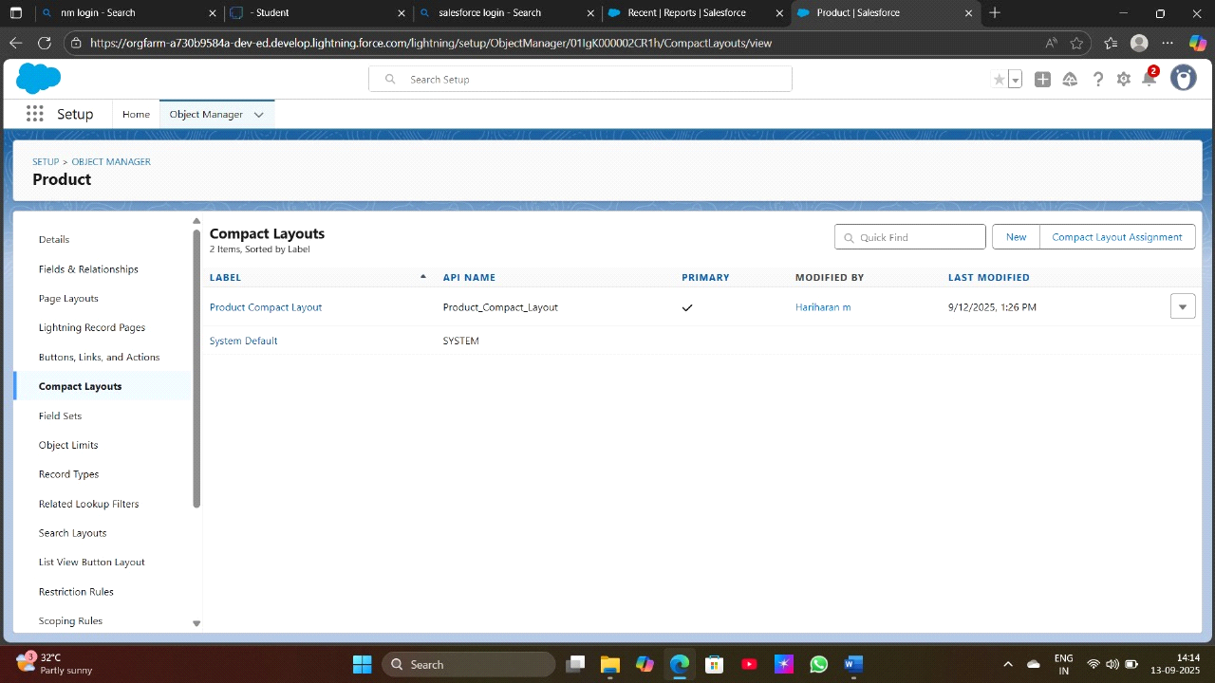

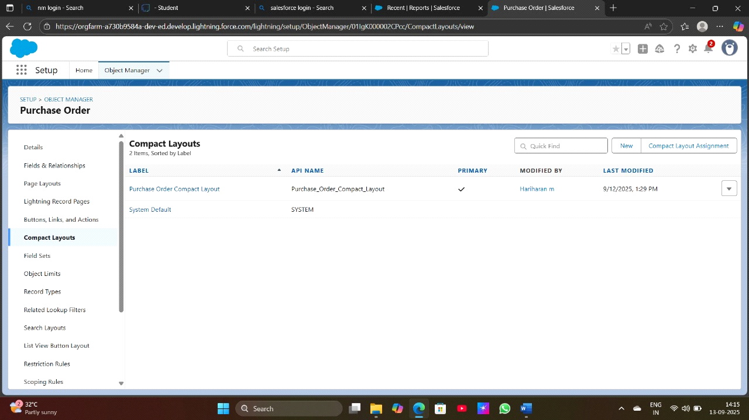

**Create a Validation Rules**

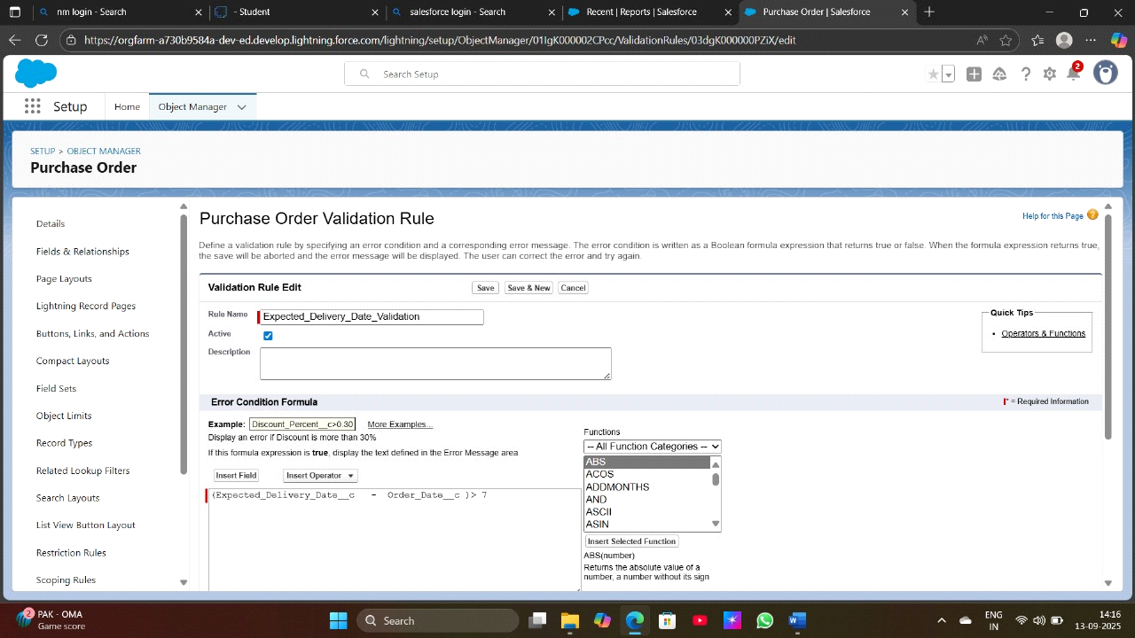

Create a Profiles

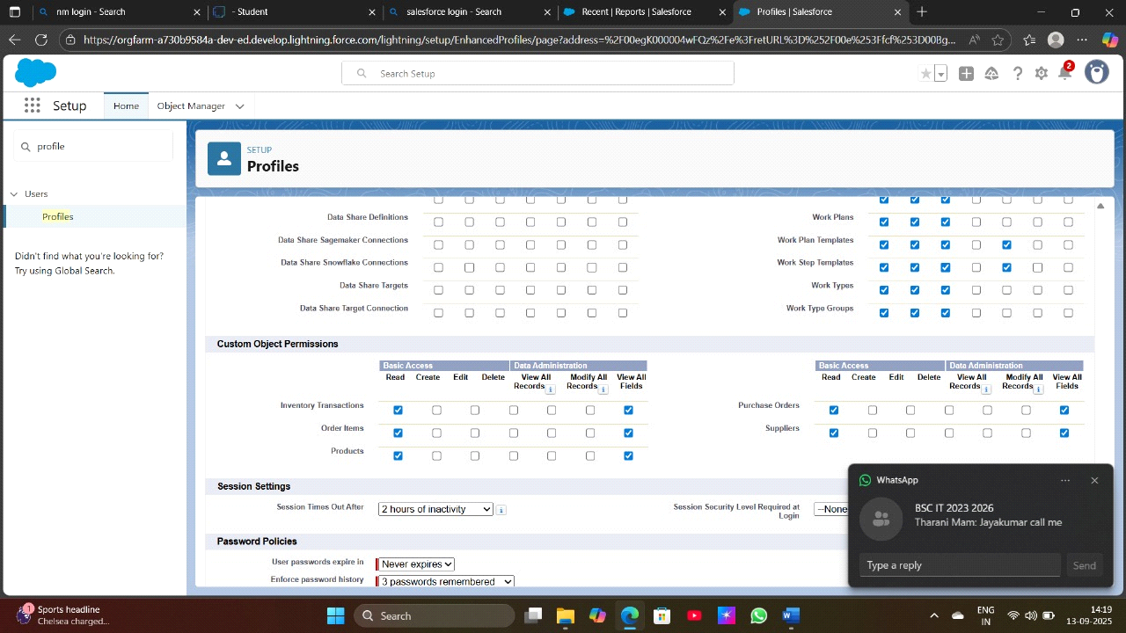

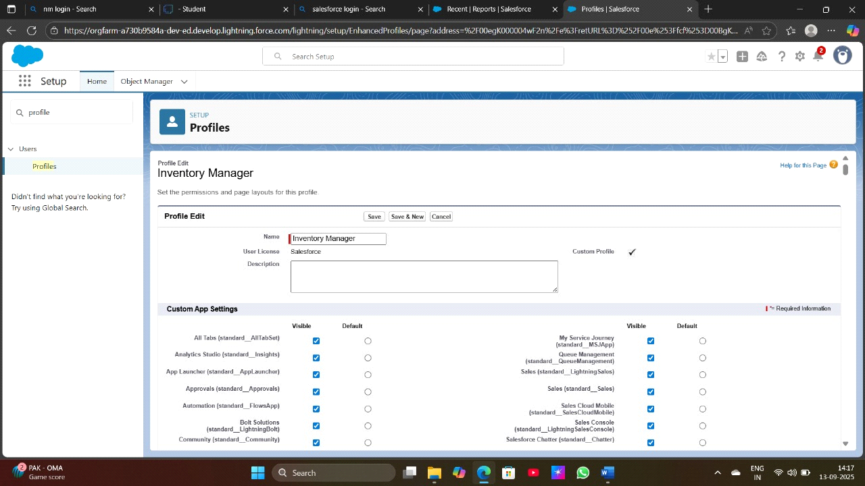

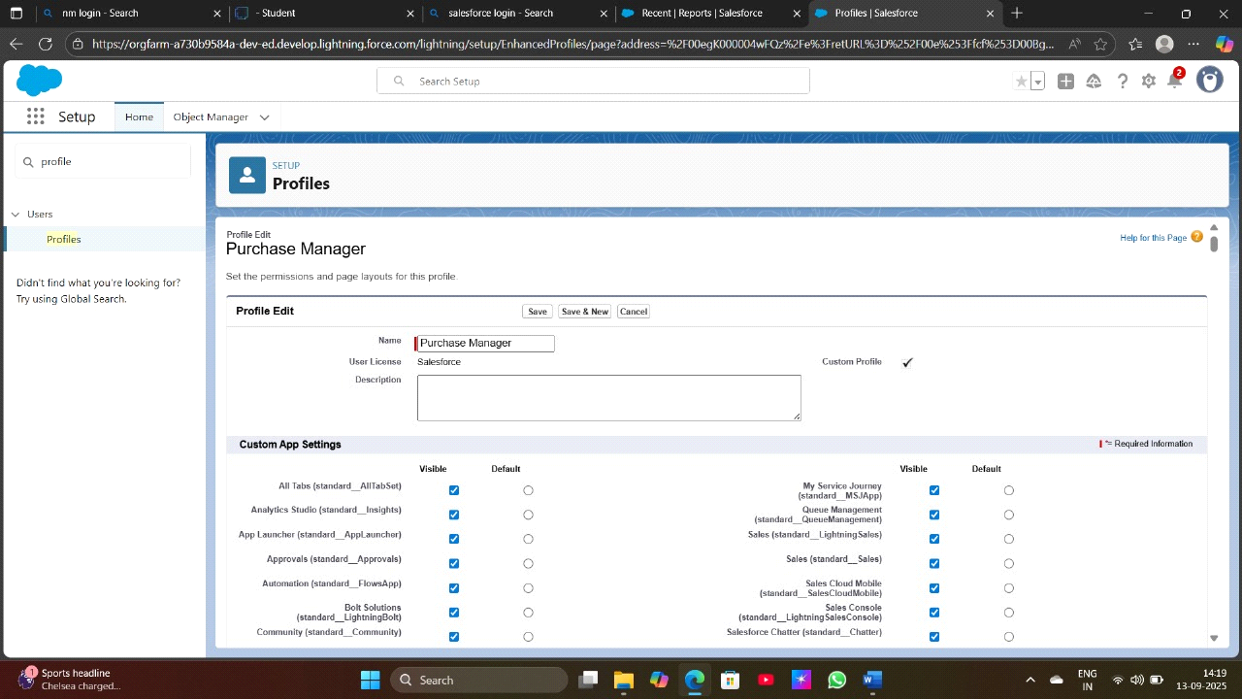

**Create a Roles**

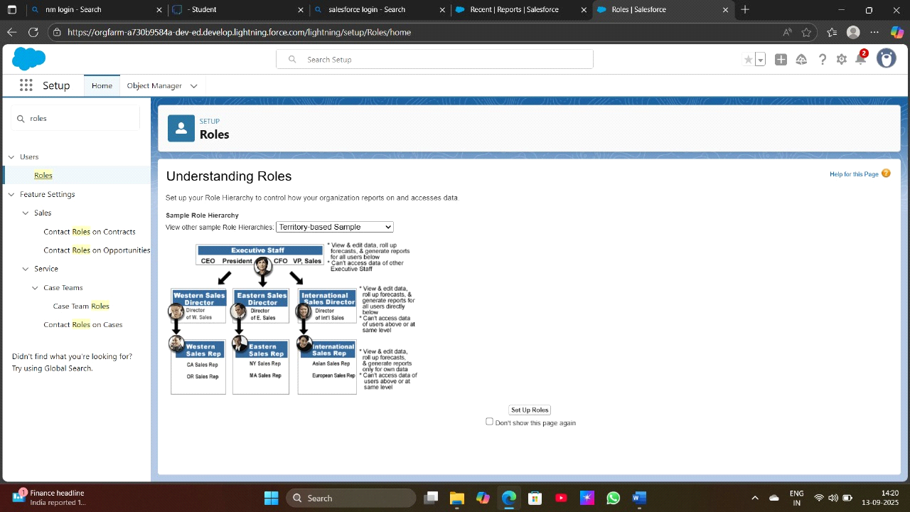

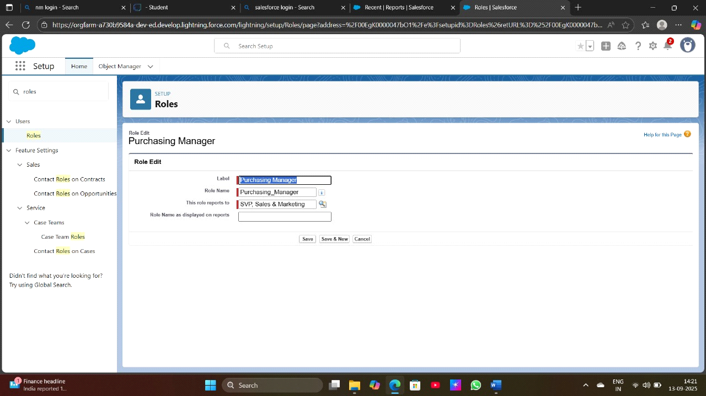

**Create a Permission Set**

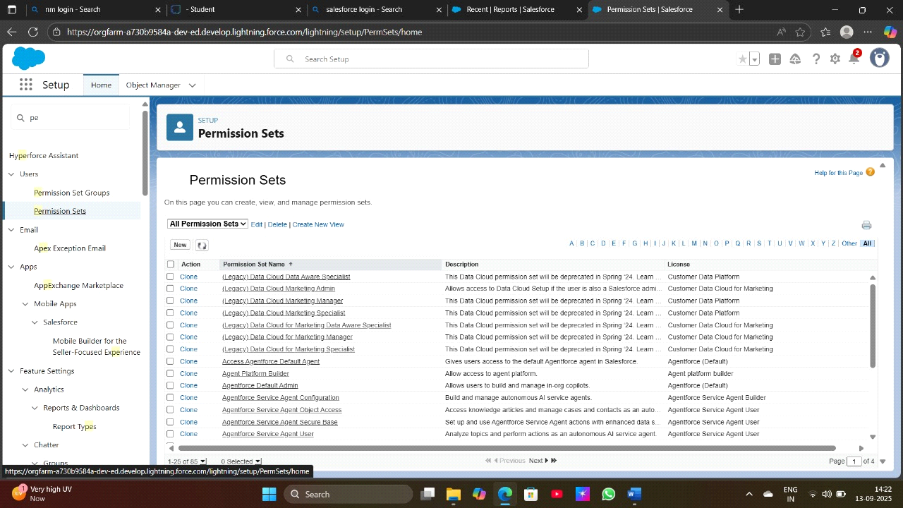

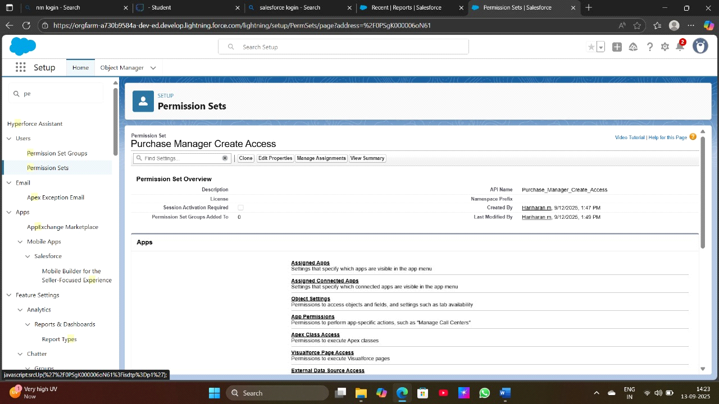

**Create Flow to update the Actual Delivery Date**

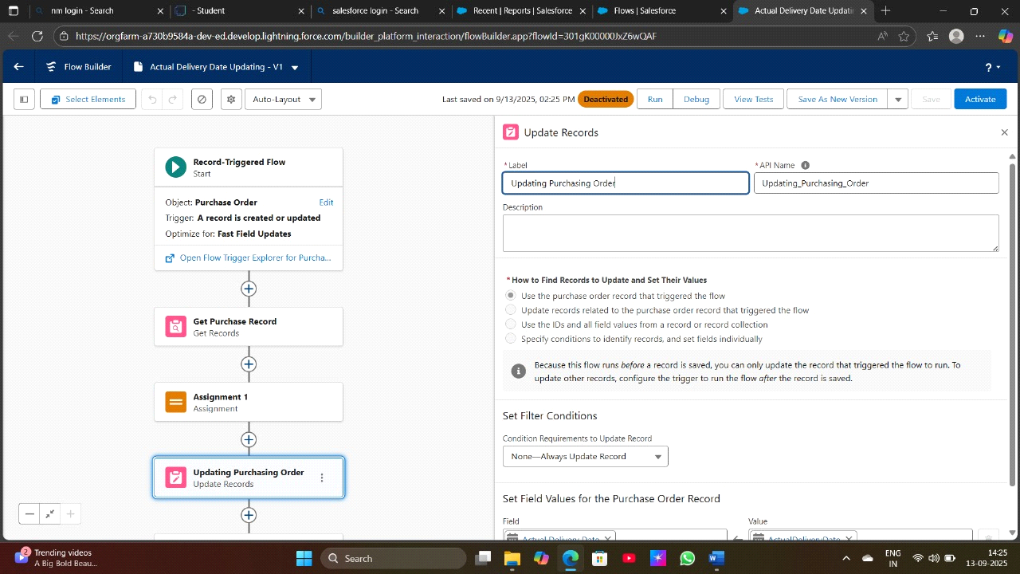

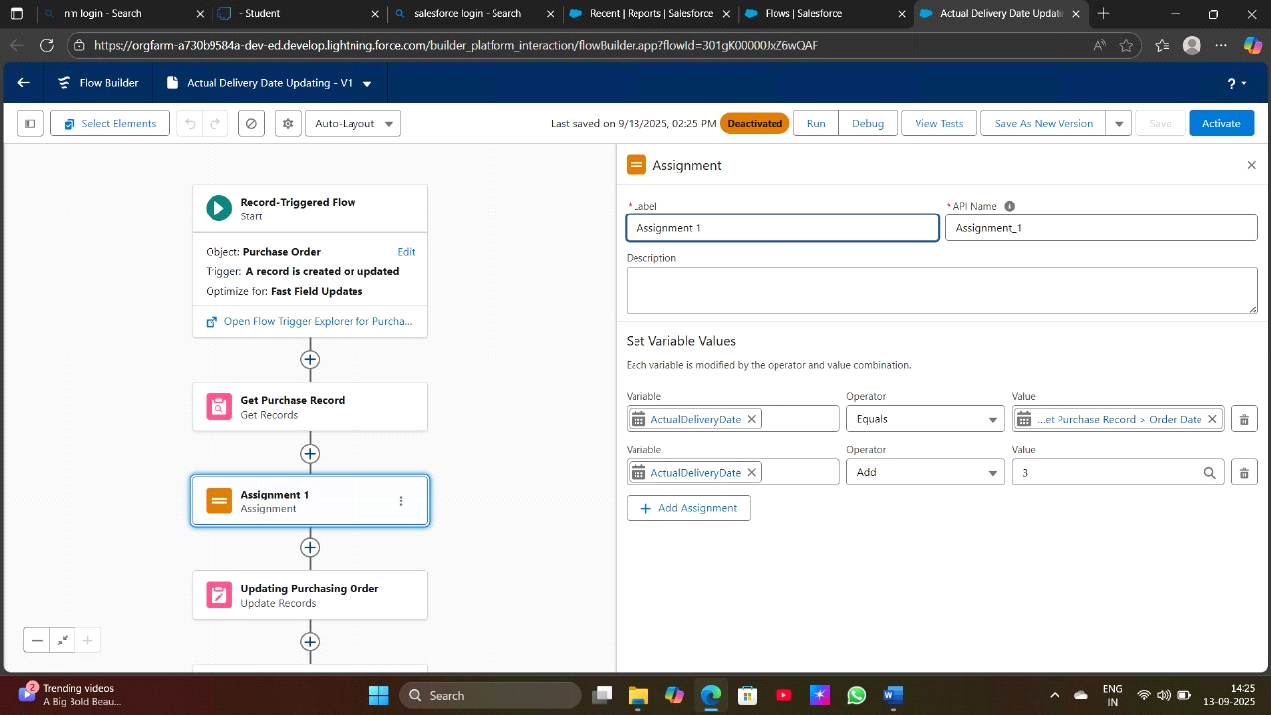

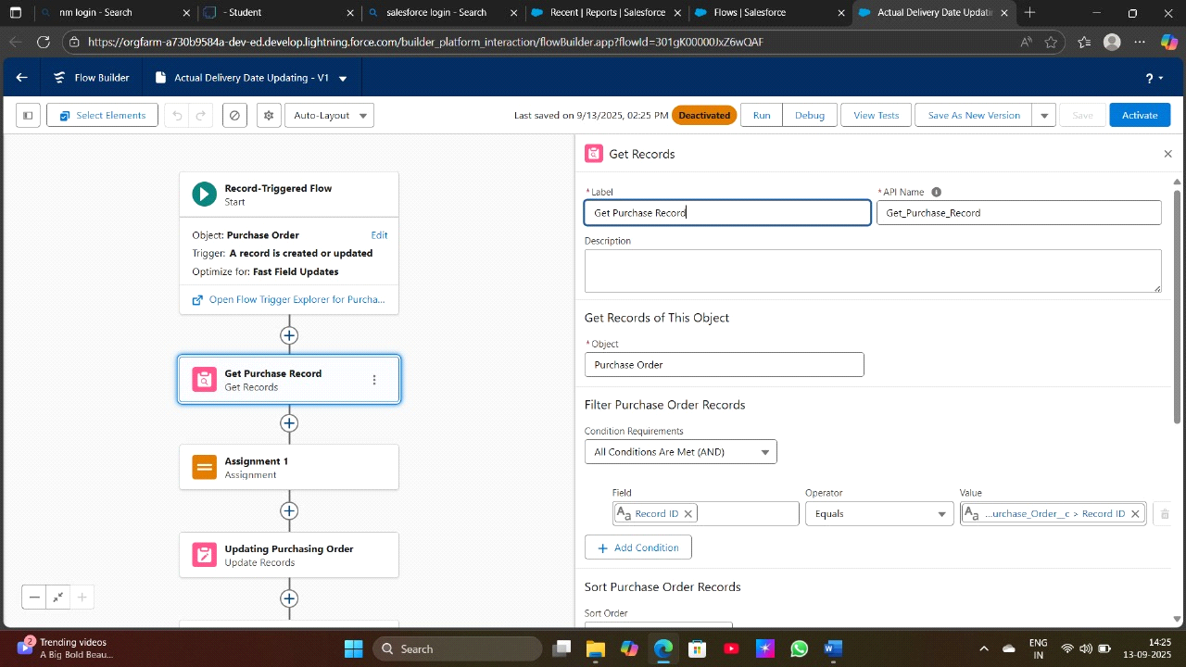

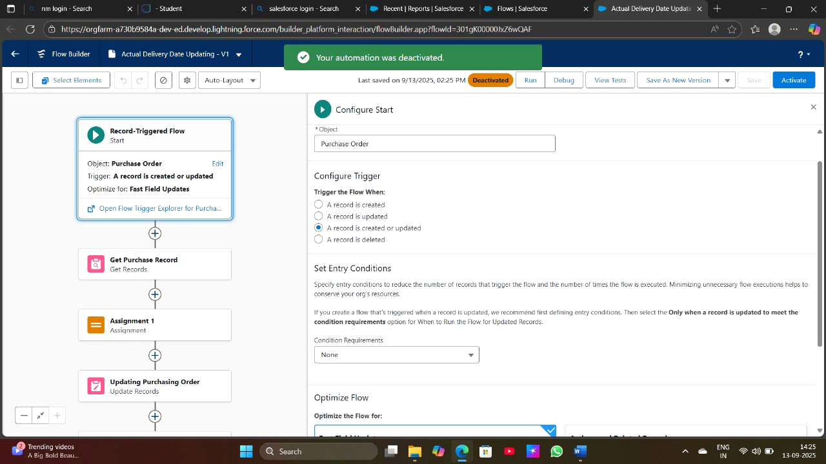

**Create a Trigger to Calculate total amount on Order Item**

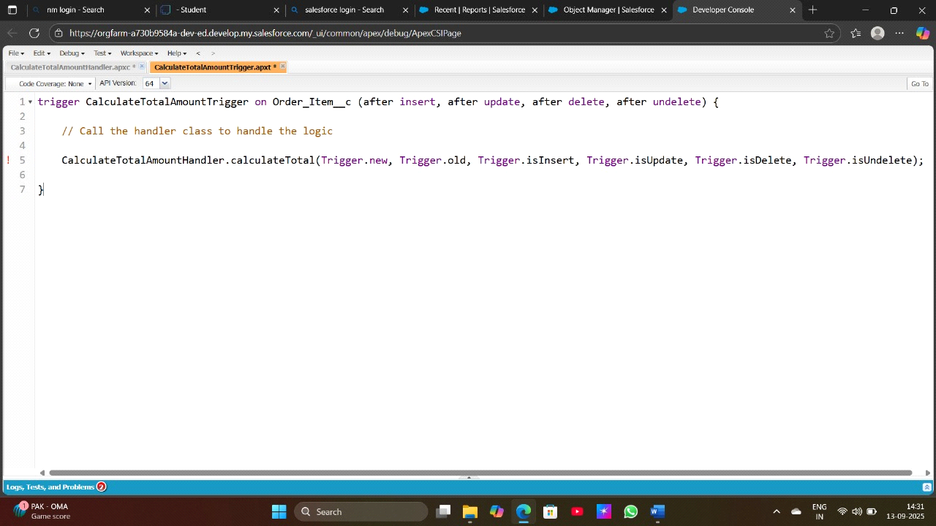

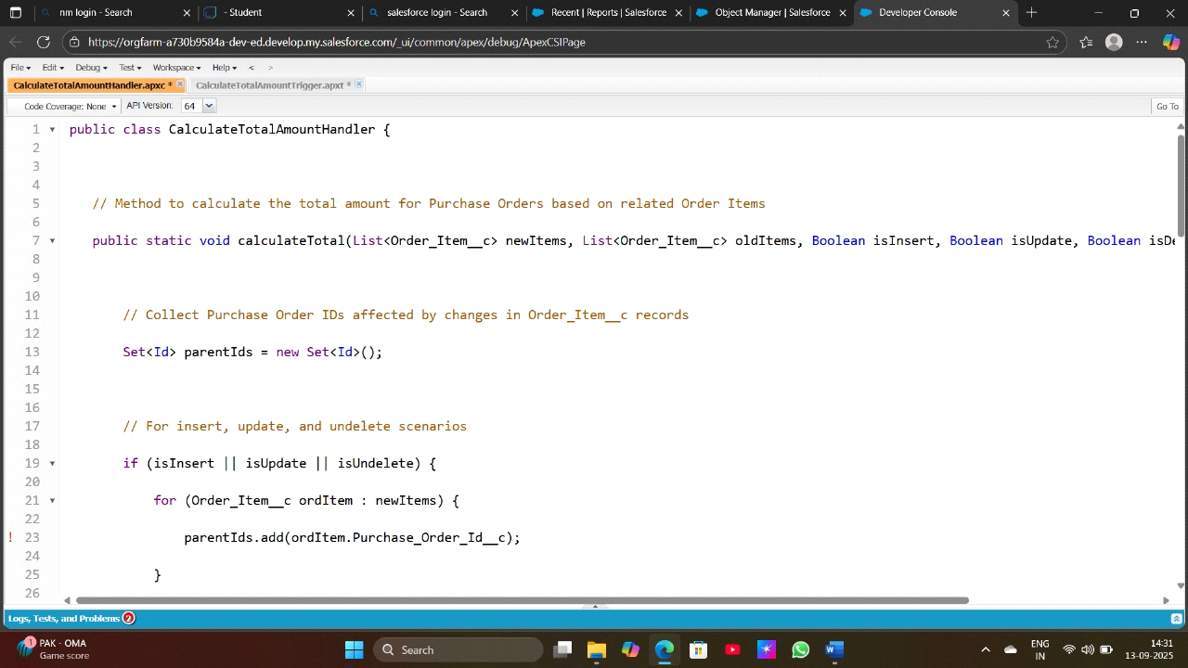

**Create a Reports**

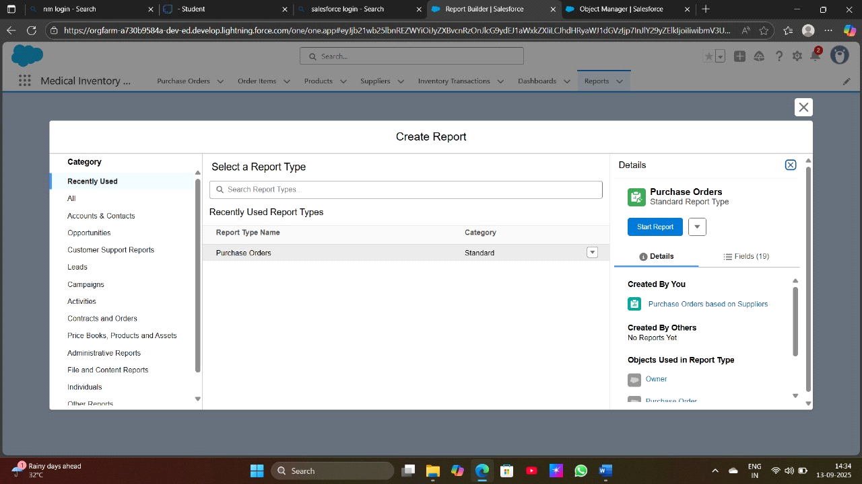

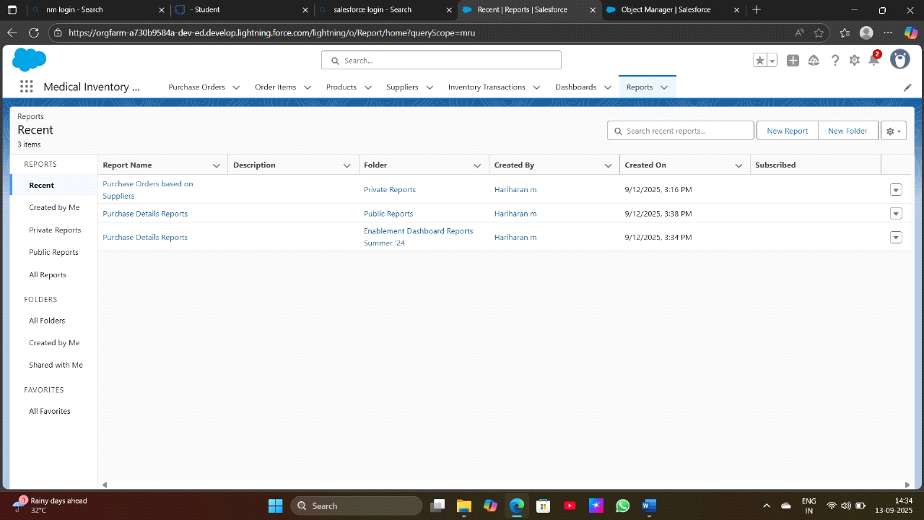

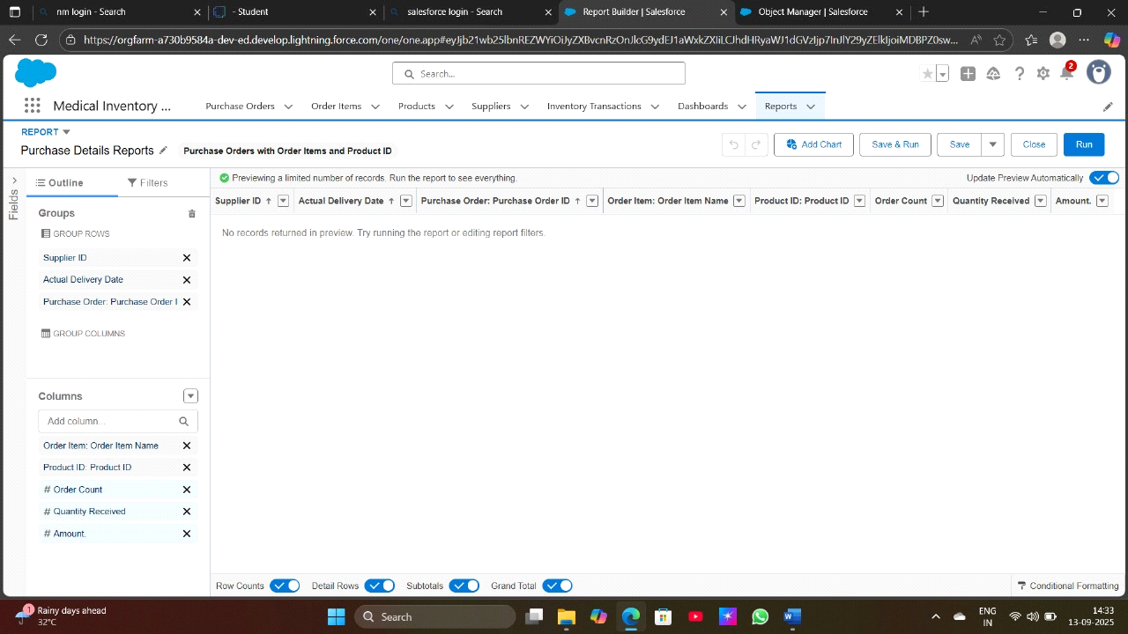

**Create a Dashboard**

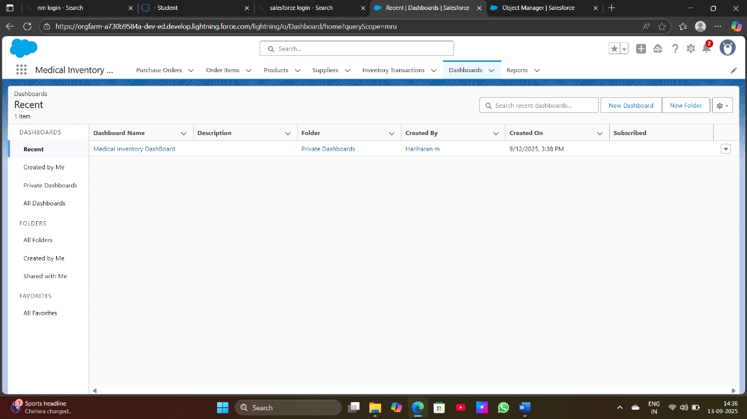

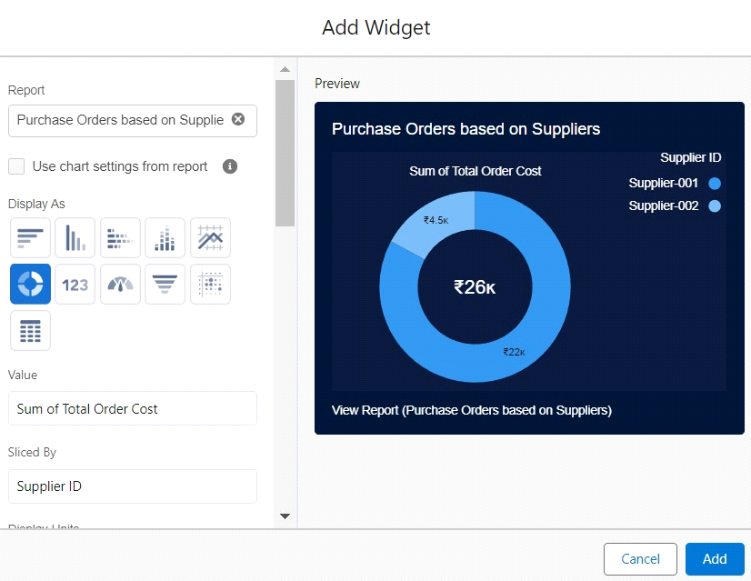

**ADVANTAGES AND DISADVANTAGE**

**ADVANTAGES**

key advantages of a Salesforce-based Medical Inventory Management System:Advantages of a Medical Inventory Management System on Salesforce

*1. Cloud-Based and Scalable*

No on-premise infrastructure needed.

Scales easily for hospitals, clinics, and pharmaceutical suppliers of all sizes.

Access the system securely from any device with internet access.

*2. Customizable to Healthcare Needs*

Tailor workflows, fields, and objects to match medical inventory requirements.

Track medicines, devices, consumables, expiration dates, batch numbers, etc.

*3. Seamless Integration with Salesforce Health Cloud*

Sync with patient records, treatment plans, and care coordination tools.

Example: Auto-update patient charts with dispensed medicine.

*4. Automated Workflows and Notifications*

Auto-trigger reordering when stock is low.

Alert staff of upcoming expirations or recalls.

Route approvals for medical purchases or controlled substances.

5*. Advanced Reporting and Analytics with Salesforce Reports & Dashboards*

Visualize stock trends, usage rates, supplier performance, etc.

Forecast demand using historical data and AI-powered predictions (Einstein Analytics).

Scan items, update counts, or report damaged goods on the go.

**DISADVANTAGES**

A Salesforce-based Medical Inventory Management System offers many advantages, but like any technology, it comes with certain disadvantages or limitations. It's important to understand these when planning or implementing such a solution.

*1. High Cost*

Licensing Fees: Salesforce licenses (especially Health Cloud or Service Cloud) can be expensive.

Customization Costs: Building a custom inventory system on Salesforce often requires skilled developers or consultants.

Ongoing Maintenance: Admins or devs are needed for updates, integrations, or changes.

2*. Complex Setup and Customization*

Salesforce is a CRM first, not a native inventory management system.

Significant customization is required to model inventory-specific logic (stock levels, warehouse locations, expiry tracking).

May need custom objects, triggers, flows, and Apex code.

*3. Steep Learning Curve*

Non-technical medical staff may find Salesforce’s interface and processes difficult to use without proper training.

Custom UIs (like Lightning components or Flows) may be required to simplify operations.

*4. Limited Offline Capabilities*

Salesforce is cloud-based and requires an internet connection.

Offline access (e.g., in remote clinics) is limited unless you build a custom offline-first app.

*5. Third-Party Dependency for Hardware Integration*

Native support for barcode scanners, RFID, or IoT devices is limited.

Requires third-party apps or integrations to connect physical devices with Salesforce.

**CONCULSION**

Implementing a Medical Inventory Management System on a powerful, flexible, and scalable solution tailored to the evolving needs of the healthcare industry. By leveraging Salesforce’s robust platform, healthcare providers can achieve real-time inventory visibility, streamline operations, enhance compliance, and ultimately improve patient care outcomes.

**APPENDIX**

Source Code : Provided in Apex Trigger

// Prepare Purchase Order trigger CalculateTotalAmountTrigger on Order_Item__c (after insert, after update, after delete, after undelete)

{

// Call the handler class to handle the logic

CalculateTotalAmountHandler.calculateTotal(Trigger.new, Trigger.old, Trigger.isInsert, Trigger.isUpdate, Trigger.isDelete, Trigger.isUndelete);

}

Step 4:

i) In the Developer Console window, go to the top menu and click on "File".

ii)Select New: From the dropdown menu under "File", select "New".

iii)Choose Apex Class: Name it as CalculateTotalAmountHandler

public class CalculateTotalAmountHandler {

// Method to calculate the total amount for Purchase Orders based on related Order Items

public static void calculateTotal(List<Order_Item__c> newItems, List<Order_Item__c> oldItems, Boolean isInsert, Boolean isUpdate, Boolean isDelete, Boolean isUndelete) {

// Collect Purchase Order IDs affected by changes in Order_Item__c records

Set<Id> parentIds = new Set<Id>();

// For insert, update, and undelete scenarios

if (isInsert || isUpdate || isUndelete) {

for (Order_Item__c ordItem : newItems) {

parentIds.add(ordItem.Purchase_Order_Id__c);

}

}

// For update and delete scenarios

if (isUpdate || isDelete) {

for (Order_Item__c ordItem : oldItems) {

parentIds.add(ordItem.Purchase_Order_Id__c);

}

}

// Calculate the total amounts for affected Purchase Orders

Map<Id, Decimal> purchaseToUpdateMap = new Map<Id, Decimal>();

if (!parentIds.isEmpty()) {

// Perform an aggregate query to sum the Amount__c for each Purchase Order

List<AggregateResult> aggrList = [

SELECT Purchase_Order_Id__c, SUM(Amount__c) totalAmount

FROM Order_Item__c

WHERE Purchase_Order_Id__c IN :parentIds

GROUP BY Purchase_Order_Id__c

];

// Map the result to Purchase Order IDs

for (AggregateResult aggr : aggrList) {

Id purchaseOrderId = (Id)aggr.get('Purchase_Order_Id__c');

Decimal totalAmount = (Decimal)aggr.get('totalAmount');

purchaseToUpdateMap.put(purchaseOrderId, totalAmount);

}

records for update

List<Purchase_Order__c> purchaseToUpdate = new List<Purchase_Order__c>();

for (Id purchaseOrderId : purchaseToUpdateMap.keySet()) {

Purchase_Order__c purchaseOrder = new Purchase_Order__c(Id = purchaseOrderId, Total_Order_cost__c = purchaseToUpdateMap.get(purchaseOrderId));

purchaseToUpdate.add(purchaseOrder);

}

// Update Purchase Orders if there are any changes

if (!purchaseToUpdate.isEmpty()) {

update purchaseToUpdate;

}

}

}

}